* **Lab Task 2:**

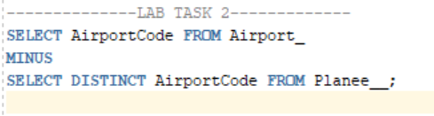List airport codes for airports that do not have planes assigned to them.

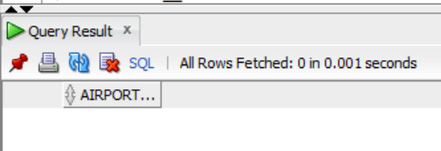OUTPUT: